ICIEA 2012 Complimentary Tour (18 July 2012)
Night Cruise at Singapore River

Itinerary：

6:00 PM: Gather at Holiday Inn Singapore Orchard City Center Hotel Lobby.

6:15 pm: Dinner time (Dinner included).

7:30 pm: Ride the boat from Clarke Quay. Singapore River is a small river flowing through the central area of Singapore. It has great historical importance as the mouth of the river was formerly the old Port of Singapore. It flows through Boat Quay and Clarke Quay two of the main entertainment scenes of Singapore. There are many colonial heritage buildings along the river. The cruise passes by many grand old bridges of diverse designs decorated with quaint old lamps of a bygone era.
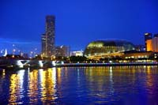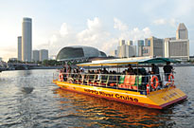

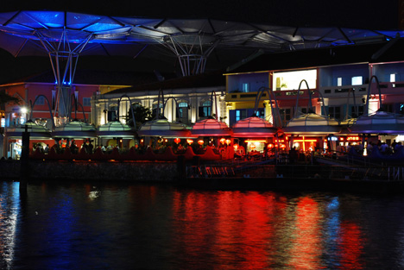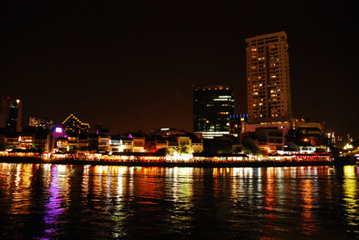

8:00 pm: Return to Clarke Quay. Proceed to Merlion Park.
Merlion is Singapore’s tourism icon, is a creature with a lion’s head and the body of a fish. The "Singa" or lion represents the animal that a Sumatran prince saw which resembled a lion, and the fish is a tribute to Singapore's history as "Temasek", the ancient sea town.
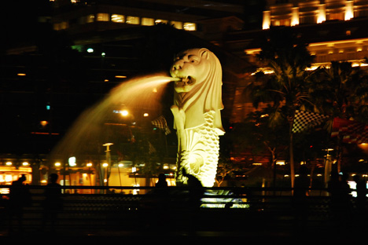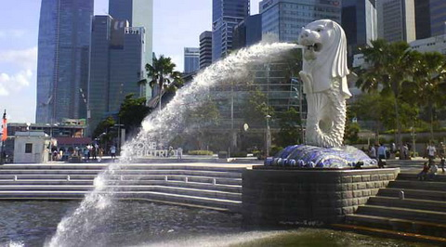

9:00 pm: Return back to Holiday Inn Singapore Orchard City Center Hotel.

Price: Delegate – Free charge Family member – S$ 28.00

